

“Python Programming”

Assignment-3

Topic – Object-Oriented Design and Robust
Programming in a Library Management System

Submitted by – Tiya Mishra
Roll no - 2501730026
Course – B. Tech CSE (AI & ML)
Section – B
Faculty name- Mr Sameer Farooq

Introduction
This project is a simple command-line Library Inventory Manager made using Python. It helps manage books by storing their details, tracking issued/available status, and saving all data in a JSON file. The program uses object-oriented programming, file handling, and basic error management to create a small but functional library system.

Objectives
-To design classes using OOP concepts.
-To store and load data using JSON.
-To build a menu-driven CLI for library operations.
-To apply exception handling and logging.
-To create a simple, real-world library management solution.

Program Description
The program contains two classes:
Book – stores title, author, ISBN, and status (issued/available). LibraryInventory – manages a list of books, adds books, searches, issues, returns, and saves data to books.json.
A menu interface allows the user to add, issue, return, view, and search books. JSON is used for permanent storage, and logging/exception handling makes the program reliable. All features are implemented inside one single Python file.

Program Code
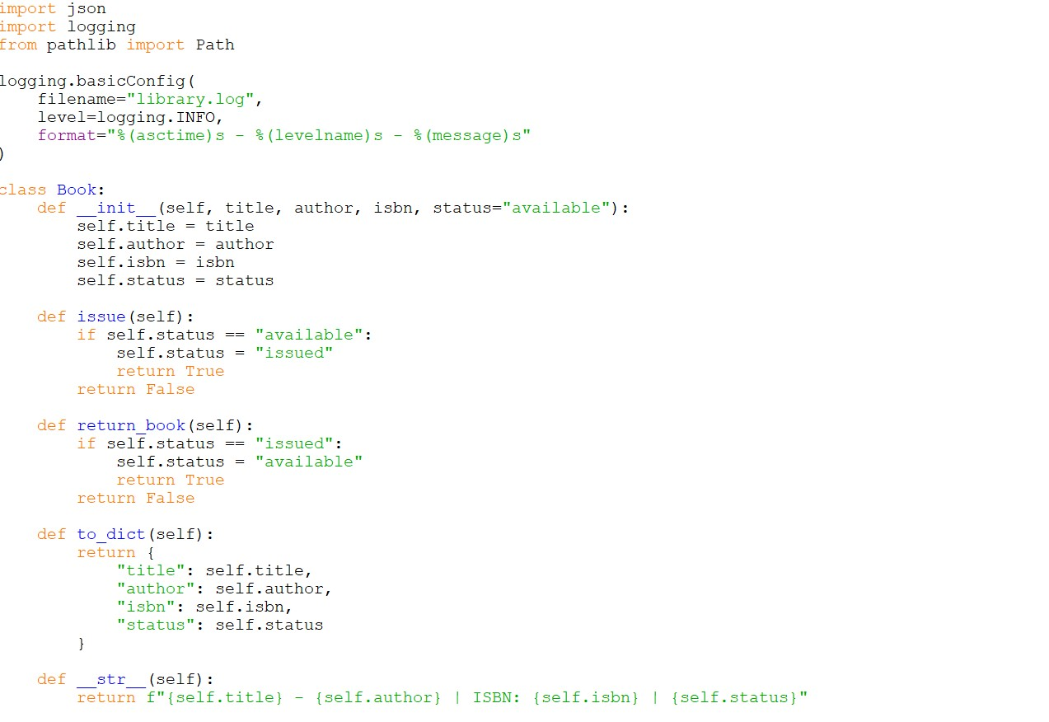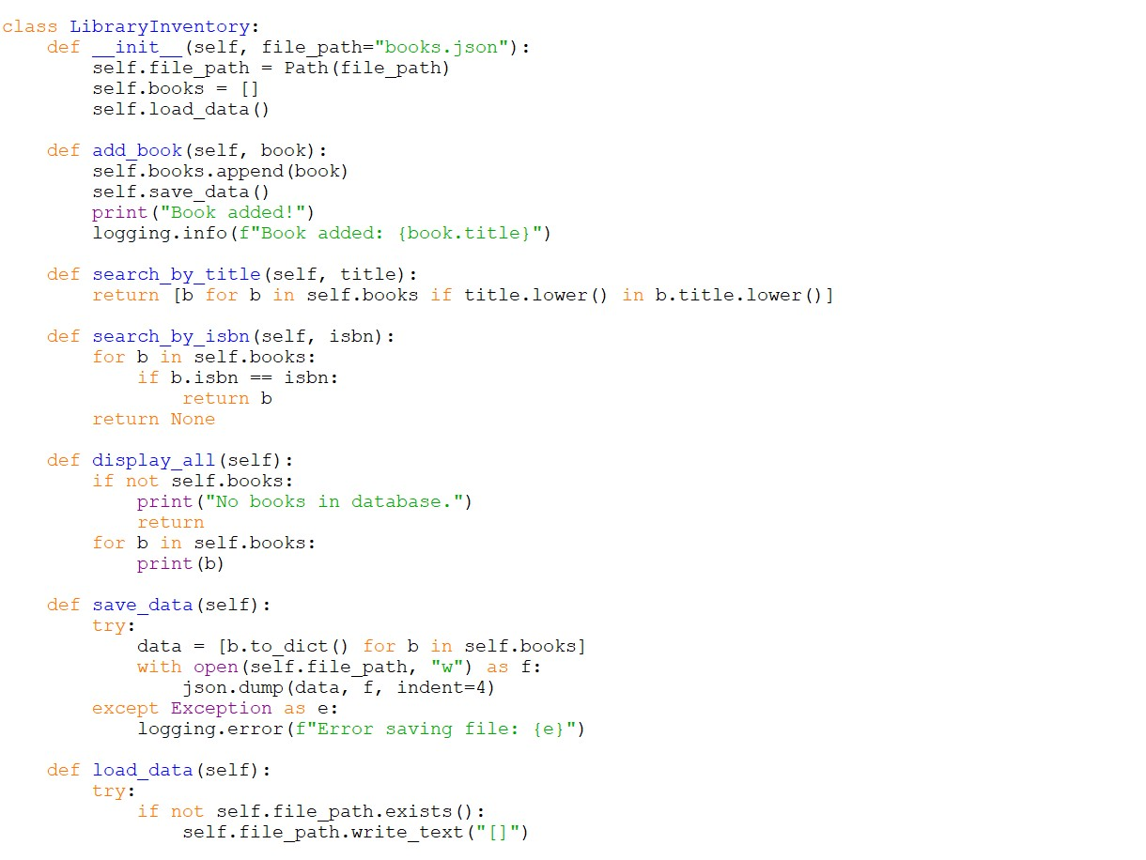

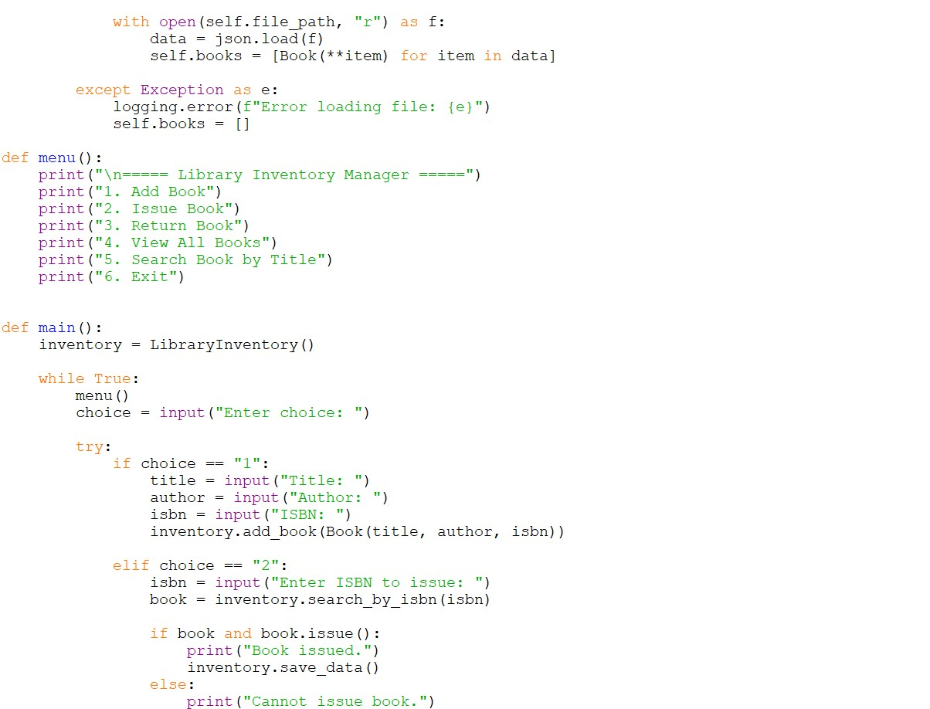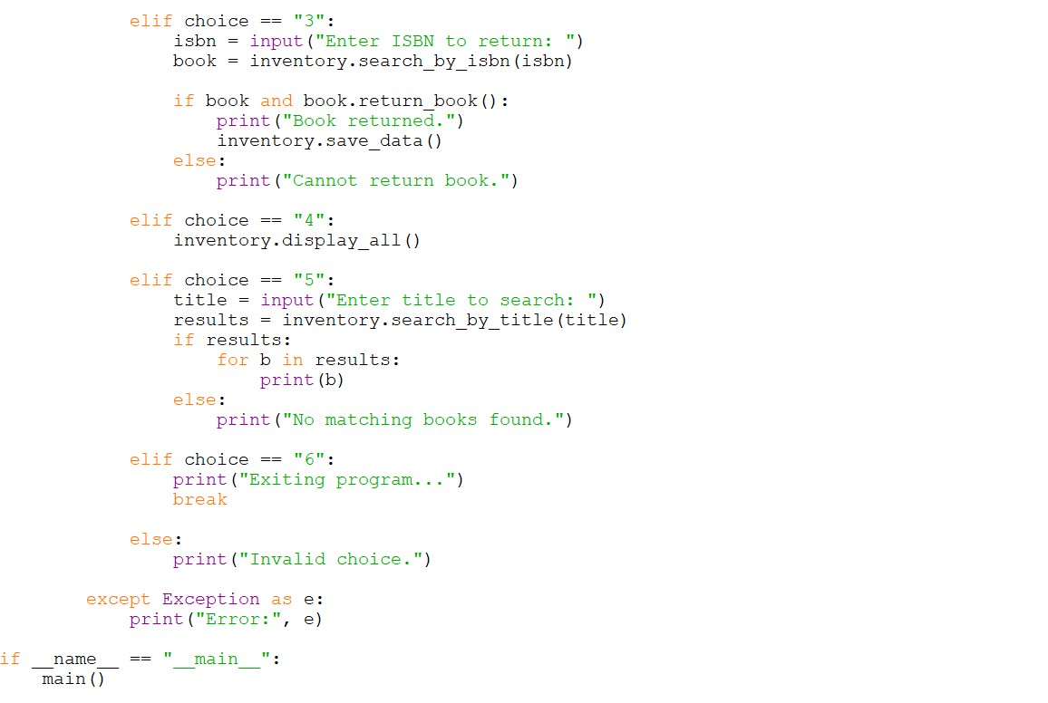

Sample Output
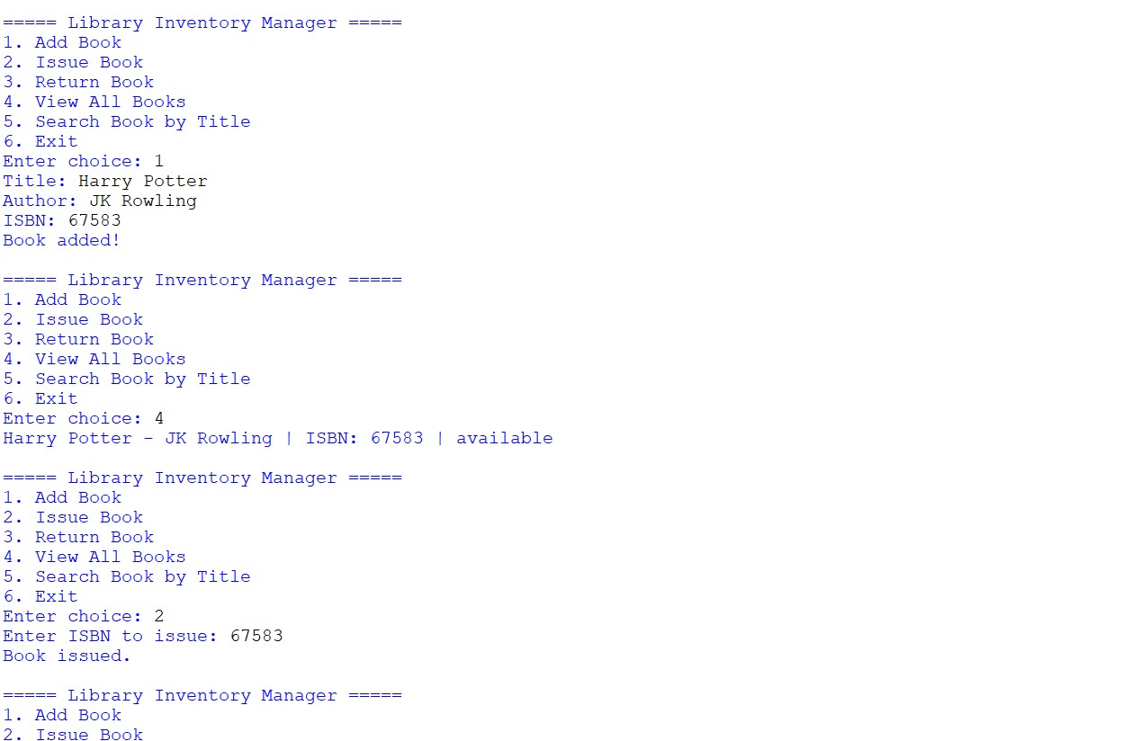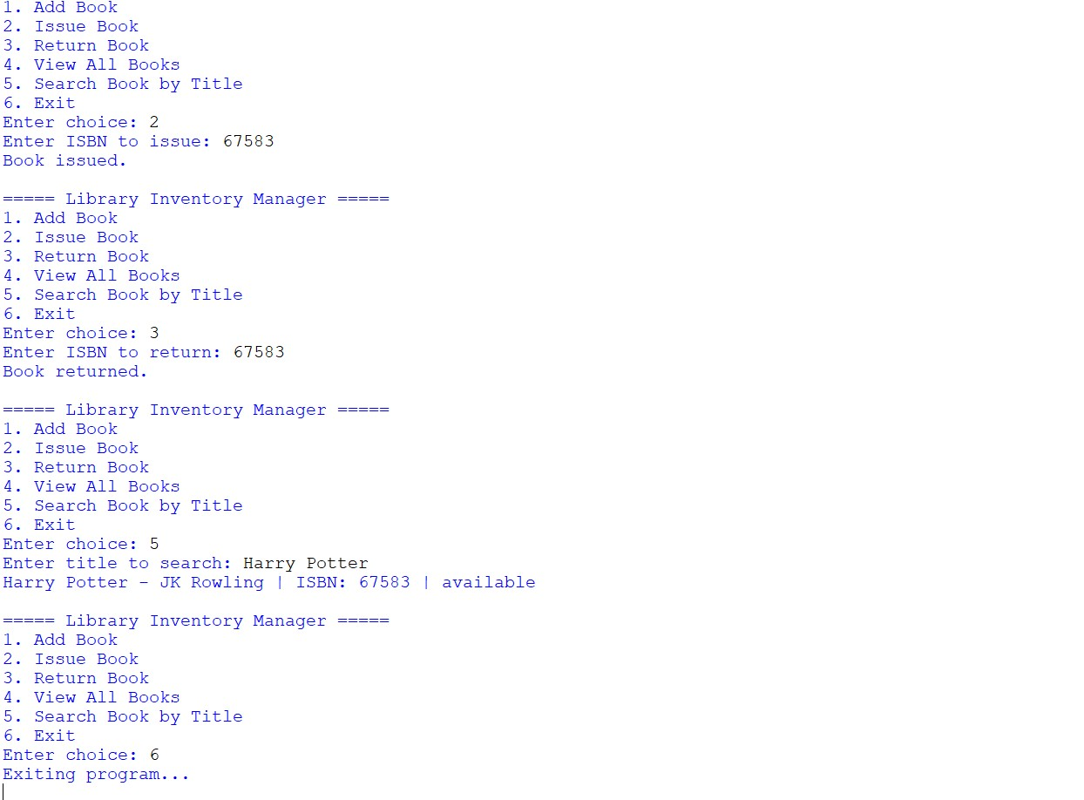

Conclusion
This project successfully demonstrates OOP, JSON file handling, CLI design, and error management in Python. It provides a simple and efficient way to manage a small library system and fulfills all assignment requirements.

